(Mini Project)

Demonstration of classification rule process on dataset PrimaryTumor.arff using j48 algorithm

Object
Demonstration of classification rule process on dataset PrimaryTumor.arff using j48 algorithm

Dataset PrimaryTumor.arff
- Age: The length of time that a person has lived. In this mini project, Three Age attribute values in between <30', '30-59', '>=60'.
- Gender: Either of the two sexes (male and female), especially when considered with reference to social and cultural differences rather than biological ones. Two Gender attribute values: Female and Male.
- Histologic Type: A description of a tumor based on how abnormal the cancer cells and tissue look under a microscope and how quickly the cancer cells are likely to grow and spread. Three values for this attribute: epidermoid, adeno, anaplastic.
- Degree-Of.Diffe: A discrimination method used to determine if an overall difference exists between test and control products when the product shows inherent variability due to preparation, production time, multiple components, etc. Three values: well,fairly,poorly.
- Bone: Any of the pieces of hard whitish tissue making up the skeleton in humans and other vertebrates. Two values: yes, no.
- Bone-Marrow: Bone marrow is the spongy tissue inside some of the bones in the body, including the hip and thigh bones. Two values: yes, no.
- Lung: Each of the pair of organs situated within the ribcage, consisting of elastic sacs with branching passages into which air is drawn, so that oxygen can pass into the blood and carbon dioxide be removed. Two values: yes, no.
- Pleura: Each of a pair of serous membranes lining the thorax and enveloping the lungs in humans and other mammals. Two values: yes, no.
- Peritoneum: The serous membrane lining the cavity of the abdomen and covering the abdominal organs. Two values: yes, no.
- Liver: A large lobed glandular organ in the abdomen of vertebrates, involved in many metabolic processes. Two values: yes, no.
- Brain: An organ of soft nervous tissue contained in the skull of vertebrates, functioning as the coordinating centre of sensation and intellectual and
Test mode: 10-fold cross-validation

=== Classifier model (full training set) ===

J48 pruned tree
------------------

neck = yes
| axillar = yes
| | abdominal = yes: stomach (2.0)
| | abdominal = no
| | | Gender = male: thyroid (3.0/1.0)
| | | Gender = female: breast (6.0)
| axillar = no
| | mediastinum = yes
| | | age = <30: lung (0.0)
| | | age = 30-59: lung (7.0)
| | | age = >=60: gallbladder (2.0)
| | mediastinum = no
| | | bone = yes
| | | | supraclavicular = yes: lung (5.0/2.0)
| | | | supraclavicular = no
| | | | | Gender = male: thyroid (2.0)
| | | | | Gender = female: esophagus (3.0/1.0)
| | | bone = no: head and neck (33.0/6.0)
neck = no
| axillar = yes
| | abdominal = yes: stomach (4.0/1.0)
| | abdominal = no
| | | Gender = male: lung (8.0/1.0)
| | | Gender = female
| | | | age = <30: lung (2.0)
| | | | age = 30-59: breast (15.0)
| | | | age = >=60: breast (0.0)
| axillar = no
| | bone = yes
| | | Gender = male
| | | | liver = yes
| | | | | mediastinum = yes: lung (9.0)
| | | | | mediastinum = no: stomach (5.0/1.0)
| | | | liver = no
| | | | | lung = yes: kidney (13.0/1.0)
| | | | | lung = no: lung (38.0/15.0)
| | | Gender = female
| | | | abdominal = yes
| | | | | lung = yes: lung (5.0/2.0)
| | | | | lung = no: liver (3.0/1.0)
| | | | abdominal = no
| | | | | lung = yes: thyroid (11.0/3.0)
| | | | | lung = no
| | | | | | supraclavicular = yes: thyroid (2.0)
| | | | | | supraclavicular = no: lung (18.0/7.0)
| | bone = no
| | | Gender = male
| | | | liver = yes
| | | | | peritoneum = yes
| | | | | | pleura = yes: colon (10.0/2.0)
| | | | | | pleura = no
| | | | | | | mediastinum = yes: pancreas (3.0/1.0)
| | | | | | | mediastinum = no
| | | | | | | | age = <30: colon (3.0/1.0)
| | | | | | | | age = 30-59
| | | | | | | | | abdominal = yes: stomach (5.0/1.0)
| | | | | | | | | abdominal = no: pancreas (5.0)
| | | | | | | | age = >=60: stomach (3.0/1.0)
| | | | | peritoneum = no
| | | | | | age = <30: lung (4.0)
| | | | | | age = 30-59
| | | | | | | lung = yes: esophagus (3.0/1.0)
| | | | | | | lung = no
| | | | | | | | histologic-type = epidermoid: lung (2.46/0.15)
| | | | | | | | histologic-type = adeno: pancreas (13.54/5.54)
| | | | | | | | histologic-type = anaplastic: pancreas (0.0)
| | | | | | age = >=60
| | | | | | | histologic-type = epidermoid: esophagus (2.55/0.55)
| | | | | | | histologic-type = adeno: lung (11.45/6.0)
| | | | | | | histologic-type = anaplastic: lung (0.0)
| | | | liver = no
| | | | | peritoneum = yes
| | | | | | abdominal = yes: lung (10.0/1.0)
| | | | | | abdominal = no: colon (6.0/4.0)
| | | | | peritoneum = no
| | | | | | abdominal = yes
| | | | | | | age = <30: lung (0.0)
| | | | | | | age = 30-59
| | | | | | | | lung = yes: pancreas (8.0/4.0)
| | | | | | | | lung = no: stomach (4.0/1.0)
| | | | | | | age = >=60: lung (6.0/2.0)
| | | | | | abdominal = no
| | | | | | | degree-of-diffe = well: kidney (5.61/1.28)
| | | | | | | degree-of-diffe = fairly: liver (1.26/0.26)
| | | | | | | degree-of-diffe = poorly
| | | | | | | | supraclavicular = yes
| | | | | | | | | mediastinum = yes: lung (7.0)
| | | | | | | | | mediastinum = no: stomach (9.18/3.59)
| | | | | | | | supraclavicular = no: lung (10.38/0.79)
| | | Gender = female
| | | | supraclavicular = yes
| | | | | liver = yes: lung (7.0/1.0)
| | | | | liver = no
| | | | | | degree-of-diffe = well: stomach (6.0/1.67)
| | | | | | degree-of-diffe = fairly: stomach (0.0)
| | | | | | degree-of-diffe = poorly: lung (3.0/1.0)
| | | | supraclavicular = no
| | | | | mediastinum = yes
| | | | | | abdominal = yes
| | | | | | | lung = yes
| | | | | | | | peritoneum = yes: lung (2.0/1.0)
| | | | | | | | peritoneum = no
| | | | | | | | | liver = yes
| | | | | | | | | | pleura = yes: colon (2.0)
| | | | | | | | | | pleura = no: pancreas (4.0/2.0)
| | | | | | | | | liver = no: kidney (3.0/1.0)
| | | | | | | lung = no
| | | | | | | | age = <30: gallbladder (0.0)
| | | | | | | | age = 30-59: corpus uteri (2.0)
| | | | | | | | age = >=60: gallbladder (7.0/4.0)
| | | | | | abdominal = no: lung (7.56/2.56)
| | | | | mediastinum = no
| | | | | | age = <30: kidney (1.0)
| | | | | | age = 30-59
| | | | | | | peritoneum = yes
| | | | | | | | lung = yes
| | | | | | | | | abdominal = yes: stomach (2.0/1.0)
| | | | | | | | | abdominal = no: pancreas (2.0)
| | | | | | | | lung = no
| | | | | | | | | liver = yes
| | | | | | | | | | abdominal = yes: pancreas (7.0/3.0)
| | | | | | | | | | abdominal = no: ovary (3.0)
| | | | | | | | | liver = no: ovary (37.0/15.0)
| | | | | | | peritoneum = no
| | | | | | | | brain = yes: rectum (2.0)
| | | | | | | | brain = no
| | | | | | | | | abdominal = yes
| | | | | | | | | | degree-of-diffe = well: pancreas (0.0)
| | | | | | | | | | degree-of-diffe = fairly
| | | | | | | | | | | liver = yes: pancreas (3.43/1.14)
| | | | | | | | | | | liver = no: corpus uteri (4.0/1.0)
| | | | | | | | | | degree-of-diffe = poorly: pancreas (5.57/0.86)
| | | | | | | | | abdominal = no: ovary (7.0/2.0)
| | | | | | age = >=60
| | | | | | | pleura = yes
| | | | | | | | lung = yes: corpus uteri (2.0)
| | | | | | | | lung = no: lung (3.0/2.0)
| | | | | | | pleura = no
| | | | | | | | peritoneum = yes: pancreas (15.0/4.0)
| | | | | | | | peritoneum = no: gallbladder (34.0/19.0)

Number of Leaves : 77

Size of the tree : 141

Time taken to build model: 0 seconds

=== Stratified cross-validation ===
=== Summary ===

Correctly Classified Instances 287 57.2854 %
Incorrectly Classified Instances 214 42.7146 %
Kappa statistic 0.502
Mean absolute error 0.0746
Root mean squared error 0.2116
Relative absolute error 59.6962 %
Root relative squared error 84.7205 %
Total Number of Instances 501

=== Detailed Accuracy By Class ===

TP Rate FP Rate Precision Recall F-Measure MCC ROC Area PRC Area Class
0.790 0.168 0.641 0.790 0.708 0.587 0.849 0.679 lung
0.964 0.019 0.750 0.964 0.844 0.841 0.971 0.689 head and neck
0.000 0.006 0.000 0.000 0.000 -0.013 0.896 0.240 esophagus
0.450 0.012 0.600 0.450 0.514 0.503 0.868 0.422 thyroid
0.385 0.047 0.488 0.385 0.430 0.376 0.807 0.382 stomach
0.333 0.036 0.370 0.333 0.351 0.312 0.828 0.321 colon
0.000 0.002 0.000 0.000 0.000 -0.005 0.724 0.104 rectum
0.545 0.070 0.492 0.545 0.517 0.455 0.872 0.471 pancreas
0.448 0.044 0.382 0.448 0.413 0.375 0.805 0.219 gallbladder
0.000 0.012 0.000 0.000 0.000 -0.022 0.667 0.088 liver
0.432 0.006 0.842 0.432 0.571 0.583 0.843 0.501 kidney
0.806 0.060 0.509 0.806 0.624 0.606 0.937 0.547 ovary
0.333 0.006 0.500 0.333 0.400 0.400 0.878 0.436 corpus uteri
0.778 0.008 0.840 0.778 0.808 0.798 0.934 0.805 breast
Weighted Avg. 0.573 0.071 0.544 0.573 0.547 0.494 0.854 0.504

=== Confusion Matrix ===
a b c d e f g h i j k l m n <-- classified as
109 1 1 3 5 2 0 8 3 2 0 1 1 2 | a = lung
0 27 1 0 0 0 0 0 0 0 0 0 0 0 | b = head and neck
5 4 0 0 2 0 0 1 0 1 0 0 0 0 | c = esophagus
7 1 1 9 0 0 0 0 0 0 1 0 0 1 | d = thyroid
7 0 0 1 20 1 1 8 3 1 0 9 0 1 | e = stomach
1 0 0 0 2 10 0 4 7 0 1 5 0 0 | f = colon
0 2 0 0 1 1 0 0 0 0 1 2 0 0 | g = rectum
7 0 0 0 5 4 0 30 3 0 0 5 1 0 | h = pancreas
5 0 0 0 0 3 0 2 13 2 0 4 0 0 | i = gallbladder
9 1 0 0 2 1 0 3 3 0 0 0 1 0 | j = liver
12 0 0 1 2 3 0 1 1 0 16 1 0 0 | k = kidney
1 0 0 0 0 2 0 3 1 0 0 29 0 0 | l = ovary
4 0 0 0 0 0 0 1 0 0 0 1 3 0 | m = corpus uteri
3 0 0 1 2 0 0 0 0 0 0 0 0 21 | n = breast

TREE
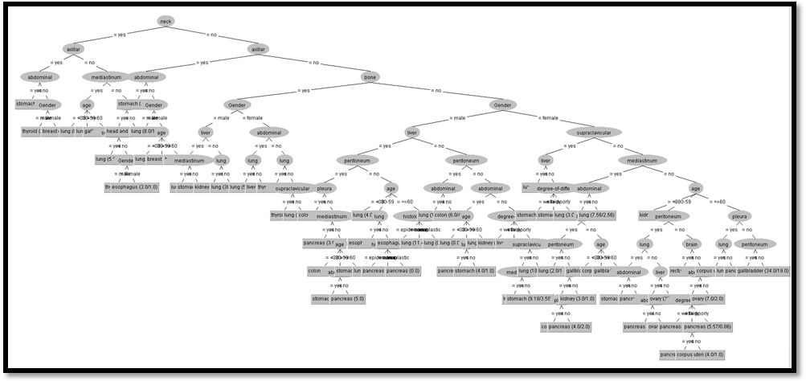

- nervous activity. Two values: yes, no.
- Skin: The thin layer of tissue forming the natural outer covering of the body of a person.Two values: yes, no.
- Neck: The part of a person's body connecting the head to the rest of the body. Two values: yes, no.
- Supreclavicular: Situated or occurring above the clavicle supraclavicular lymph nodes. Two values: yes, no.
- Axillar: The cavity beneath the junction of the arm or and shoulder containing the axillary artery and vein, a part of the brachial plexus of nerves, many lymph nodes, and fat and areolar tissue especially : armpit. Two values: yes, no.
- Mediastinum: The area between the lungs. Two values: yes, no.
- Abdominal: Relating to the abdomen, the belly, that part of the body that contains all of the structures between the chest and the pelvis. Two values: yes, no.
- Class: Class attribute contains 14 values. The above 17 attributes are dependent on the class attribute. The values are as follows: lung, 'head and neck', esophagus, thyroid, stomach, colon, rectum, pancreas, gallbladder, liver, kidney, ovary, 'corpus uteri', breast.

The following screenshot shows the classification rules that were generated when j48 algorithm is applied on the given dataset.

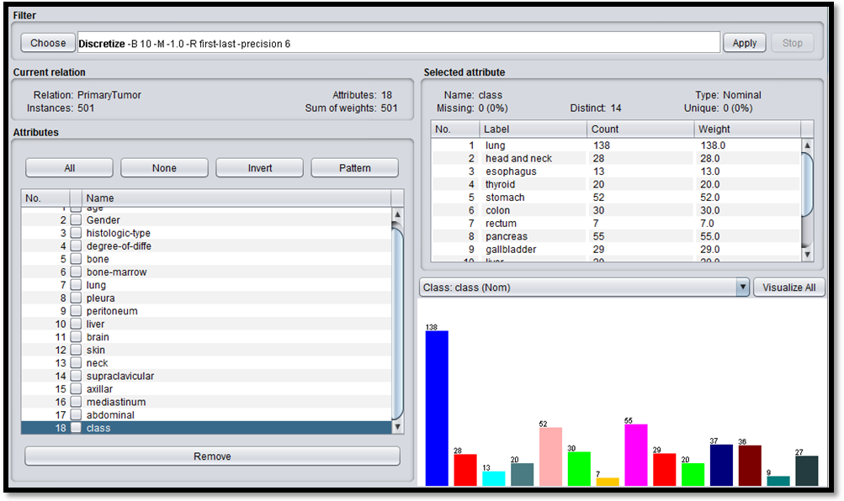
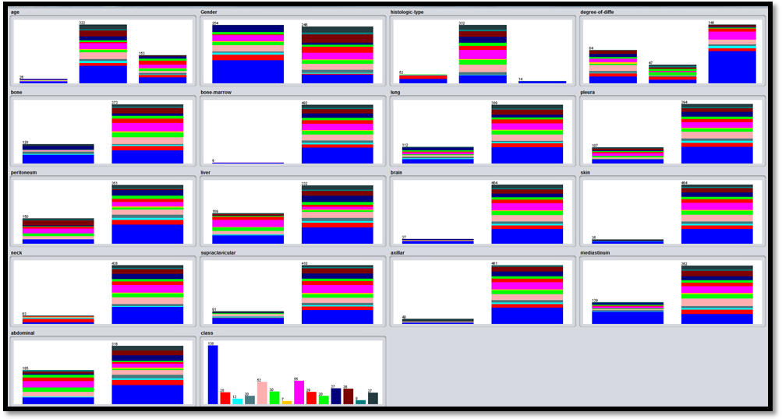
J48 Algorithm
=== Run information ===

Scheme: weka.classifiers.trees.J48 -C 0.25 -M 2
Relation: PrimaryTumor
Instances: 501
Attributes: 18
age
Gender
histologic-type
degree-of-diffe
bone
bone-marrow
lung
pleura
peritoneum
liver
brain
skin
neck
supraclavicular
axillar
mediastinum
abdominal
class

